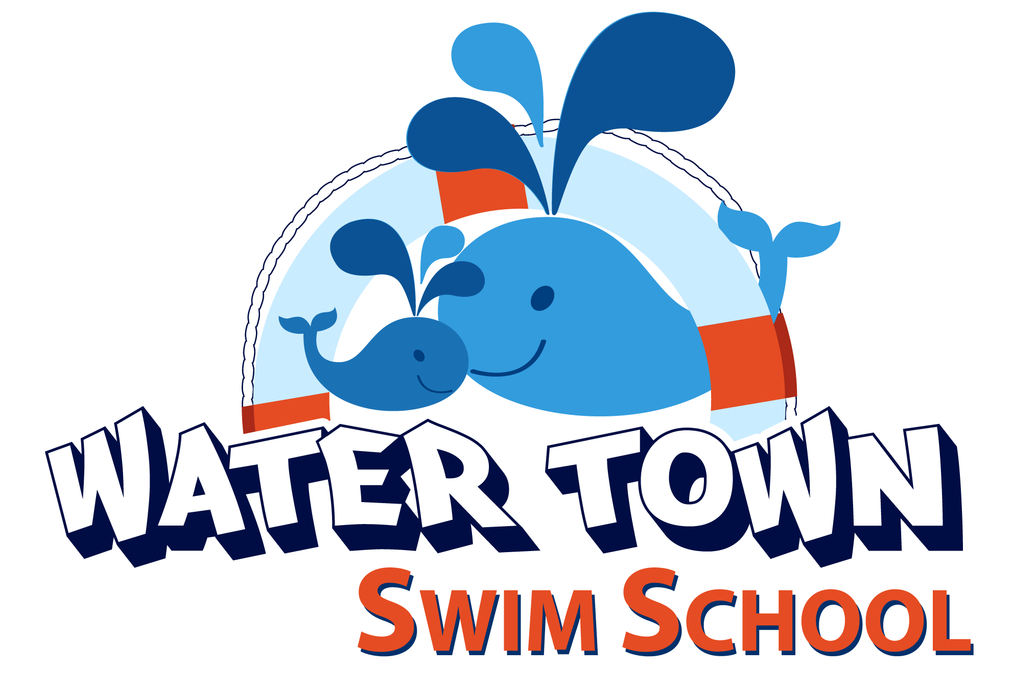
Infant and Toddler Swim Classes
www.watertownswimschool.com
watertownswimschool@gmail.com
+918527211937

WHAT TO BRING

- Bathing suit for you and your child.
- Towel for you and your child. Towels are not provided. If you take a towel from a hotel you will be charged at their rate.
- Children under 36 months regardless if they are potty trained must wear a swim diaper. If your child is not wearing a swim diaper they will not be permitted into the pool or get a makeup class.
- Children may wear goggles but it is not required. We generally only recommend goggles once they know how to swim.
- Sunblock
- Sun hat (optional)
- You may want to bring a long sleeve shirt for your child to help maintain their body temperature. If you have a long-sleeved bathing suit this is fine too if you don't just have a long sleeve T-shirt and pants. However, the hotel requires that a bathing suit be worn underneath.
- Parents are recommended to wear a loose-fitting cotton T-shirt over their bathing suit
- We recommend having a snack handy after swim class or purchasing something from the hotel.

GENERAL

- Learning to swim is the beginning of a lifelong journey… the steps your child is taking along the path can only be taken at their own pace. Water familiarisation, being confident in the water, learning the basic life-saving skills and water safety are the basic building blocks and pave the way for the road ahead.
- Above all it must be a fun, positive experience for all concerned. We will never force your child to do anything they are not ready for; however we will set boundaries so that they are aware of what is expected of them.
- Parents or a pre-agreed carer will generally be in the pool with their child. Please respect their comfort levels as we do.
- Parents/carers do not have to be able to swim however they must feel comfortable standing in water up to chest height while holding your child.
Enjoy!

POOL RULES

- Please wait for the teacher/assistant to let you into pool area
- Do not enter the pool unless invited by the teacher/ parent.
- No diving into the shallow end of the pool unless it is a seated dive from the side or a standing dive from the in-pool platform and only when the teacher asks you.
- Always look and listen to your teacher.
- Always show good manners and be kind to other children. Share!
- Infants 36 months and below (or older if not toilet trained) must wear an approved reusable swim diaper regardless if they are potty trained.
- Walk in the cement pool area, do not run.
- Please do not have any family members trying to get your child’s attention while they are in class to take a picture of video. You may take pictures and videos at any point during the class but do so without calling out to the child as it interrupts them and others in the class. Journalistic photography is ok!
- Please keep track of siblings who are not in the swim lesson, they may not stick their feet in the water and should not interfere with the class if they are not enrolled in the class.
- Please keep food and water to a minimum in the pool area. Please keep water and all other drinks in a non glass container.
Being a Good Swimming Parent

- Please come at least 10 minutes early for your lesson so your child is relaxed and you have time to change, do last minute essentials etc. If you are coming for the first time please arrive 15 minutes early, ensure the forms are completed by a Water Town Swim School member (including Medical Forms and Waiver. To save time you can also complete and email us back before class.
- Make sure your child goes to the toilet just before their lesson.
- Make sure your child is ready (if used, goggles placed on their head – not eyes).
- Explain and discuss pool rules with your child.
- Give your child positive comments after their lesson (see below).
- Time between lessons is limited. If the teacher cannot quickly deal with your inquiry, please email and someone will ring you later.
Being Positive

It is important to reinforce the positive points of your child’s lesson. At night, during family time (with your child present), please tell other family members the positive things your child did in his/her lesson.

This is still important even if your child was crying or didn’t get into the water. Please find something your child did well e.g. Sitting quietly playing with the toys or helping to tidy up etc.

Being positive and pleased with your child’s efforts will assist in making swimming a positive, enjoyable experience and therefore maximize learning. It is best NOT to speak in front of the child about their negative reactions such as crying. Remember, children have elephant ears so even speaking on the phone in another room, they may still be listening even if they are just 1 year old. Children understand much more than parents think! If you say, “they hated it! They just cried the whole time!” Expect more of the same the next class as children believe what their parents tell them.

Commonly asked questions

Q: What is your makeup policy?
A: No makeups, regardless of injury, family emergency or weather will be allowed

Q: What if my child cries the entire class?
A: It’s not a rare thing so first of all, DON’T BE EMBARASSED! Second, everything is a learning experience. If all your child wants to do is sit on the side and play with toys watching the class, don't push too much. Allow them to watch, try and make it fun. And practice things at home to prepare them for the next class. Show them swim videos and practice cup conditioning, get them use to showers. Still have questions? Email or call us for an answer!

